**Assignment -4**

Distance Detection Using Ultrasonic Sensor

|  |  |
| --- | --- |
| Assignment Date | 25 October 2022 |
| Student Name | Pachigulla deepthi |
| Student Roll Number | 720819104080 |
| Maximum Marks | 2 Marks |

**Question-1:**

Write code and connections in wokwi for ultrasonic sensor. Whenever distance is less than 100 cms send "alert" to IBM cloud and display in device recent events. WOKWI LINK: https://wokwi.com/projects/346502216516895315

**CODE:**

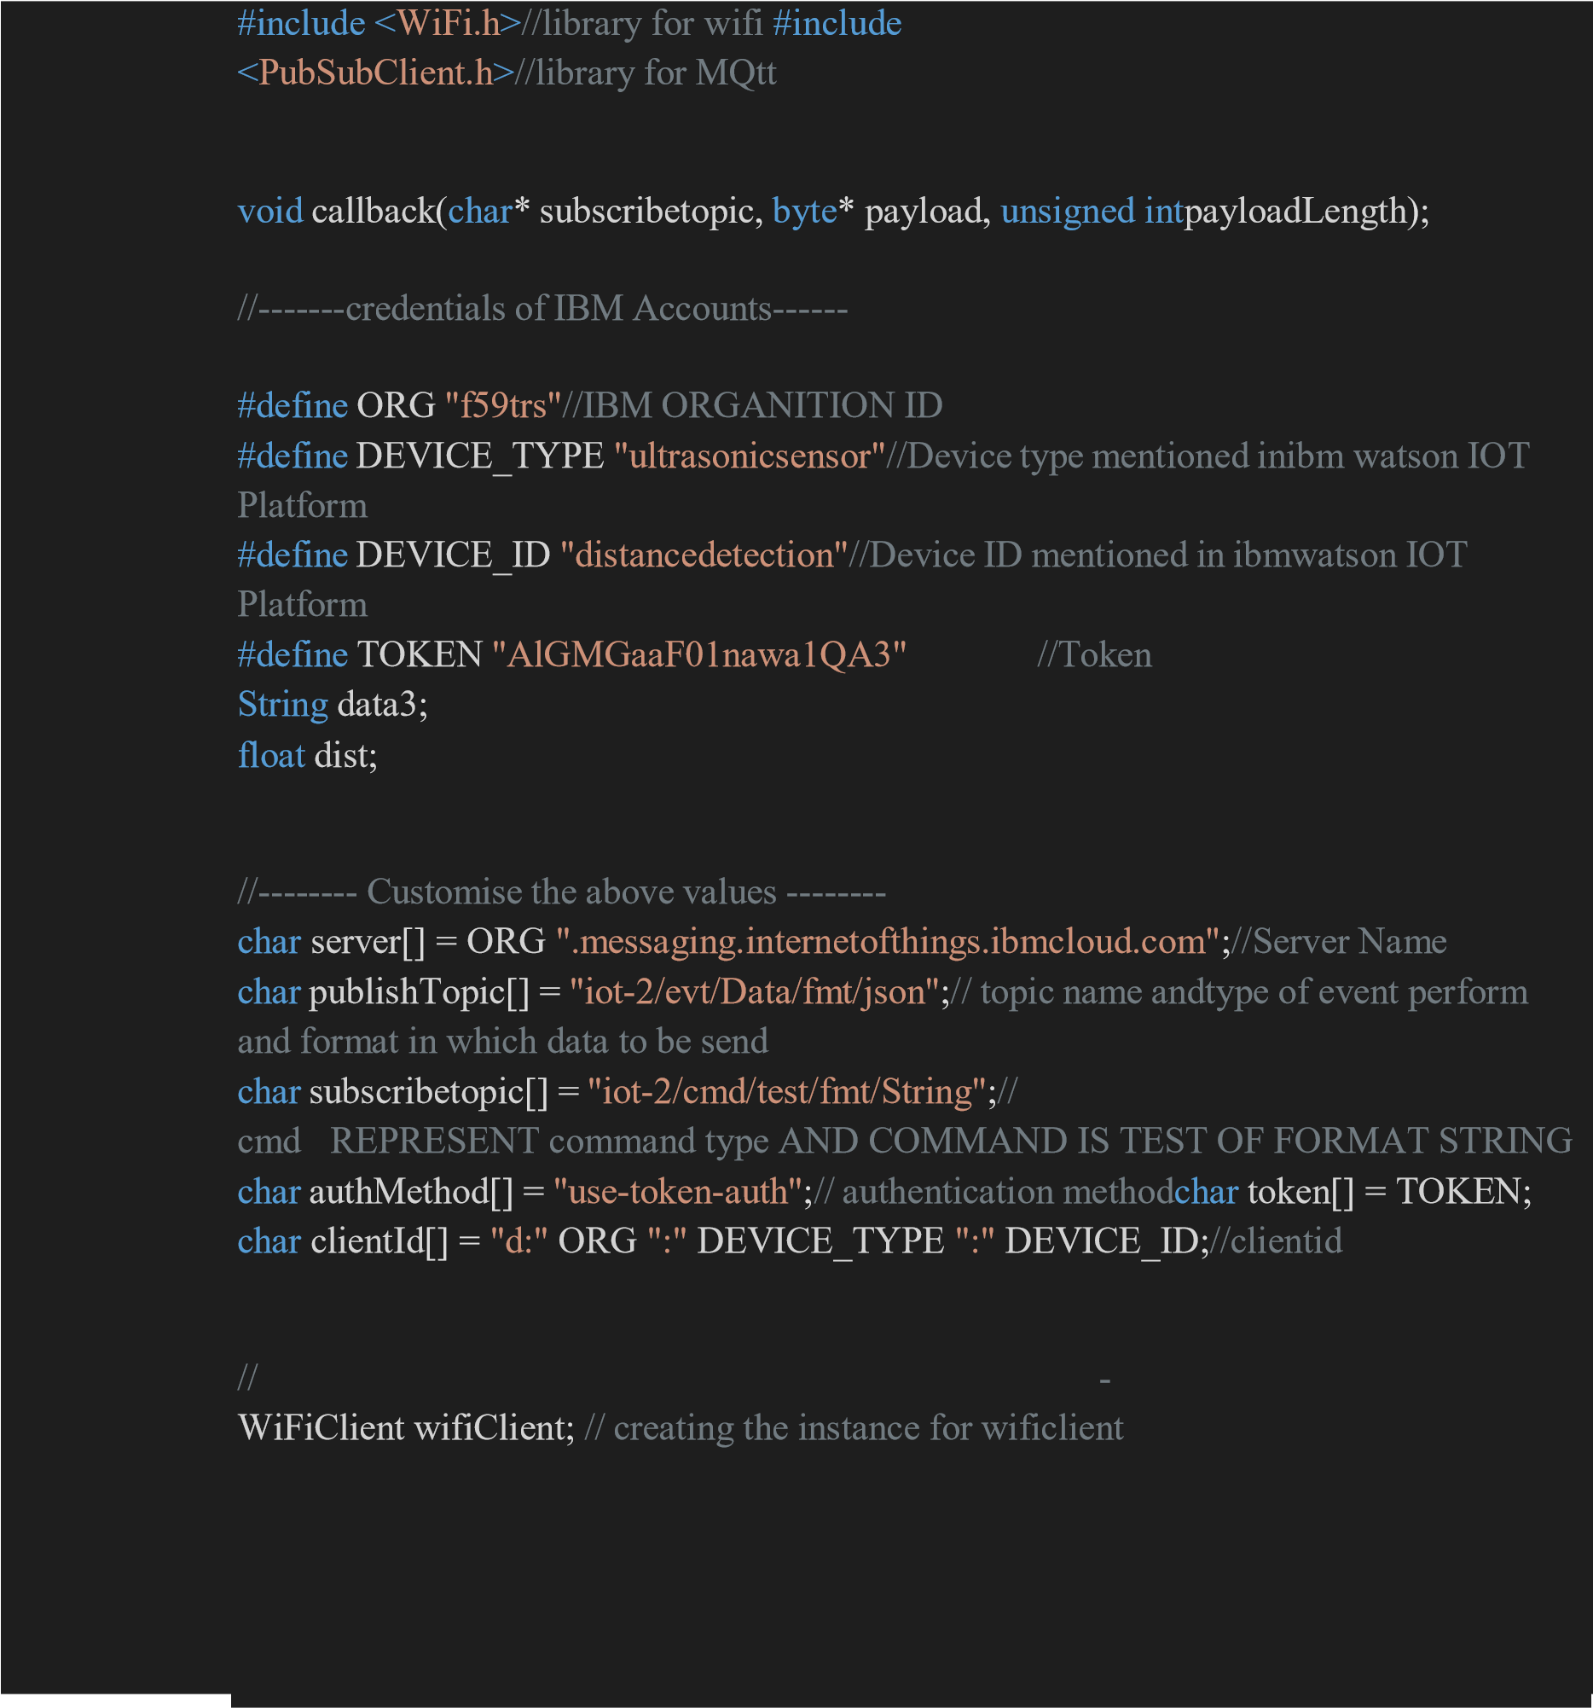

|  |
| --- |
| PubSubClient client(server, 1883, callback ,wifiClient);  //calling the predefined client id by passing parameter like server id,portand wificredential  int LED = 4; int trig = 5; int echo =  18; void setup()  {  **Serial**.begin(115200); pinMode(trig,OUTPUT); pinMode(echo,INPUT); pinMode(LED, OUTPUT);  delay(10); wificonnect(); mqttconnect();  }  void loop()// Recursive Function  {  digitalWrite(trig,LOW); digitalWrite(trig,HIGH); delayMicroseconds(10); digitalWrite(trig,LOW);  float dur = pulseIn(echo,HIGH); float dist = (dur * 0.0343)/2; **Serial**.print  ("Distancein cm"); **Serial**.println(dist);  PublishData(dist); delay(1000); if (!client.loop()) { mqttconnect();  }  }  /*.....................................retrieving to  Cloud. ................................................................... */  void PublishData(float dist) { mqttconnect();//function call for connecting to ibm  /* creating the String in in form JSon to update the data to ibm cloud  */  String object; |

|  |
| --- |
| if (dist <100)  { digitalWrite(LED,HIGH);  **Serial**.println("object is near"); object = "Near";  } else  { digitalWrite(LED,LOW); **Serial**.println("no object found"); object = "No";  }  String payload = "{\"distance\":"; payload += dist;  payload += "," "\"object\":\""; payload += object; payload += "\"}";  **Serial**.print("Sending payload: "); **Serial**.println(payload);  if (client.publish(publishTopic, (char*) payload.c_str())) {  **Serial**.println("Publish ok");// if it sucessfully upload data on the cloud then it will print publish ok in Serial monitor or else it will print publish failed  } else {  **Serial**.println("Publish failed"); }  }  void mqttconnect() { if (!client.connected()) { **Serial**.print("Reconnecting client to "); **Serial**.println(server);  while (!!!client.connect(clientId, authMethod, token)) {  **Serial**.print("."); delay(500);  }  initManagedDevice();  **Serial**.println();  }  } |

|  |
| --- |
| void wificonnect() //function defination for wificonnect {  **Serial**.println(); **Serial**.print("Connecting to ");  WiFi.begin("Wokwi-GUEST", "", 6);//passing the wifi credentials to establish the connection while (WiFi.status() != WL_CONNECTED) { delay(500);  **Serial**.print(".");  }  **Serial**.println(""); **Serial**.println("WiFi connected"); **Serial**.println("IP address: "); **Serial**.println(WiFi.localIP());  }  void initManagedDevice() { if (client.subscribe(subscribetopic)) { **Serial**.println((subscribetopic)); **Serial**.println("subscribe to cmd OK");  } else {  **Serial**.println("subscribe to cmd FAILED");  }  }  void callback(char* subscribetopic, byte* payload, unsigned int payloadLength) {  **Serial**.print("callback invoked for topic: "); **Serial**.println(subscribetopic);  for (int i = 0; i < payloadLength; i++) {  //Serial.print((char)payload[i]); data3 +=  (char)payload[i];  }  // Serial.println("data: "+ data3);  // if(data3=="Near")  // {  // Serial.println(data3);  // digitalWrite(LED,HIGH);  // }  // else  // {  // Serial.println(data3); |

// digitalWrite(LED,LOW);

// }

data3="";

}

**OUTPUT:**

# When object is not near to the ultrasonic sensor

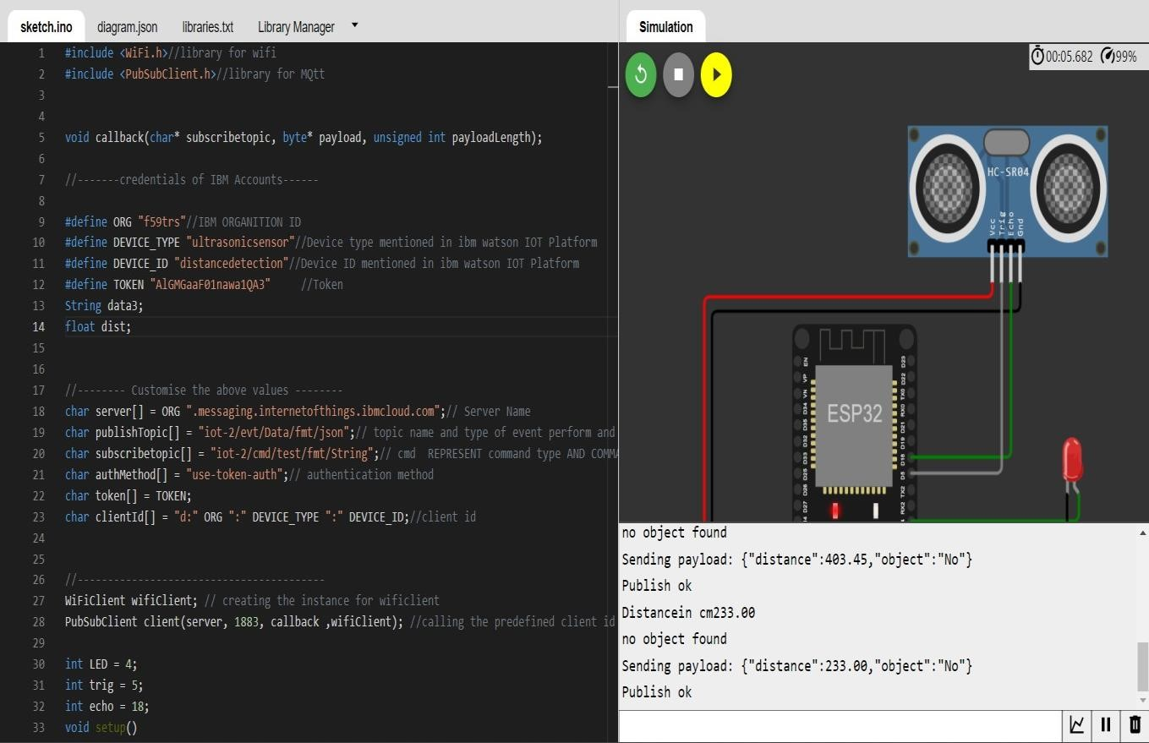

# Data sent to the IBM cloud device when the object is far

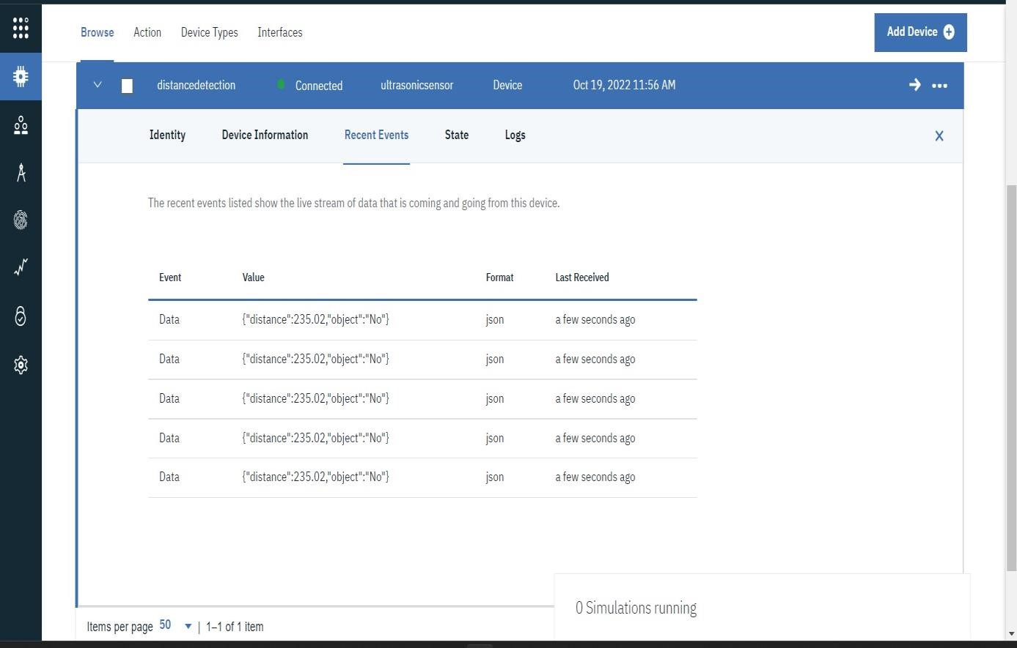

# When object is nearer to the ultrasonic sensor

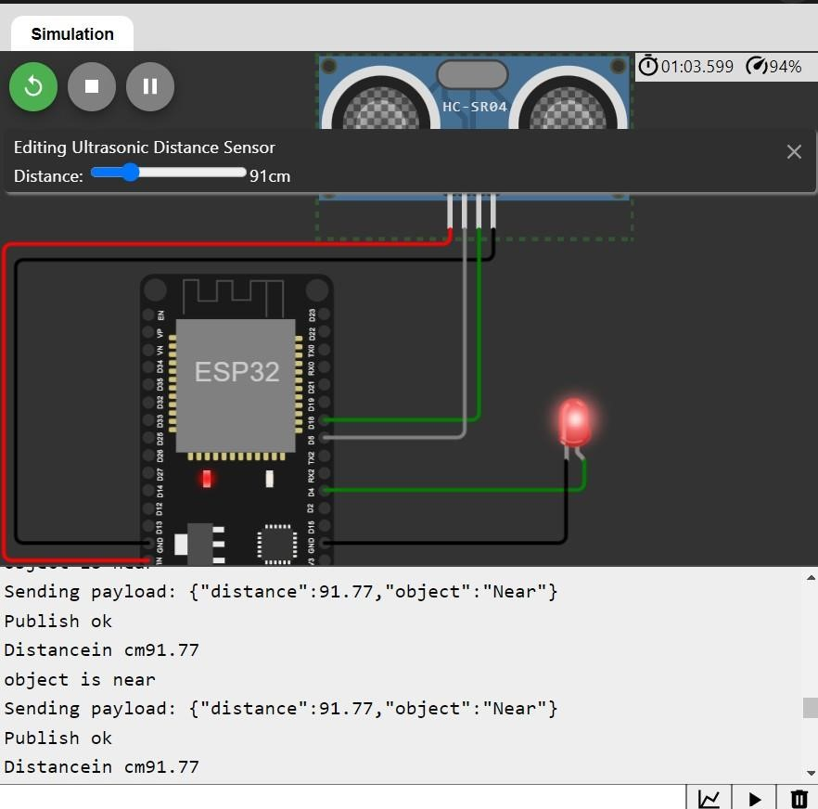

# Data sent to the IBM cloud device when the object is near

